|  |  |
| --- | --- |
|  | **Guidelines**  **for**  **Practice Check Case Study Specification**  **Version 1.0** |
|  |
|  |

Table of Contents

1.0 Guidelines for Case study specification 3

1.1 Scope: 3

2.0 Evaluation Guidelines 6

2.1 Evaluation criteria: 6

# Guidelines for Case study specification

## Scope:

The scope of this document is to provide the guidelines to be followed for creating case study specification

1. **User stories** : The case study requirements have to be created as Agile User Stories

**Eg: refer sample user story given below**



1. **Hardware/Software Requirements:** The hardware and Software requirements have to be specified which are needed for setting up the environment

**<<add the hardware and software requirements here>>**

1. **UI specification – UI tier - Screen Flow:** The screen flow needs to follow the below guidelines
   1. The UI screens to be created have to be added in this section
   2. The UI screen should contain the fields that are required for capturing user

input

* 1. Each UI screen should provide field level specification listing field name,

field type, field description

* 1. Field leve validations and event handlers have to be defined for each UI screen

**Sample UI Screen along with Field level specification given below**

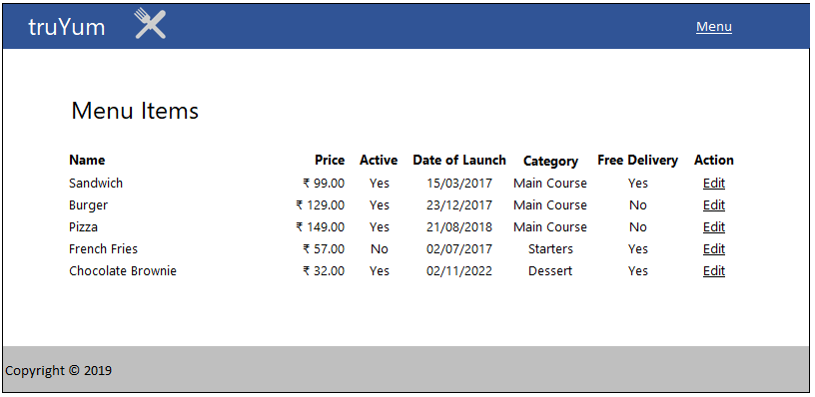

**Field Specification**

|  |  |  |
| --- | --- | --- |
| **Field Name** | **Field Type** | **Description** |
| Name | Label | Displays the title of the menu item |
| Price | Label | Display the price of the menu item in currency format with two decimal places. Should include the currency symbol as well. |
| Active | Label | Display ‘Yes’ or ‘No’ based on whether the item is in stock or not |
| Date of Launch | Label | Display date of expiry in DD/MM/YYYY format |
| Category | Label | Displays the category of the menu item |
| Free Delivery | Label | Display ‘Yes’ or ‘No’ based the respective menu item delivery status |
| Action | Link | Display ‘Edit’ as a link that points to edit-MenuItem.html |

1. **Middleware Specification – Business tier :** The middleware specification needs to follow the below guidelines
   1. The business tier should contain the necessary class diagrams for the business entities to be developed as part of the case study project

* 1. Each class should specify the Access specifier, member variables and functions to be created aligning to the requirement stated in the user story
  2. Interface should specifiy the method definitions to be created as per the requirement.
  3. Coding standards/naming conventions and best programming practices that can be adopted will follow the industry standards.

**Few examples given below**

**HTML:**

1. HTML5 semantic tags has to be used wherever applicable. Avoid using div tags for header, footer, article and navigation bar.
2. Document Type should be defined as

<!DOCTYPE html>

**CSS:**

1. CSS files names should be style.css
2. Reuse styles wherever applicable. Potential areas are Application Name, Page Title, Form Fields and Buttons

**JAVASCRIPT:**

1. JavaScript file name should **script.js**
2. Use camelCase for variables and functions.

var firstName = "John";

function alert() {

alert("This is an alert message.");

}

1. **Database Specification – Data Access tier :** The Database specification needs to follow the below guidelines
   1. The data access tier should contain the necessary ER diagrams for the business entities to be developed as part of the case study project
   2. The tables that are to be created as per the business requirement should be listed in order.
   3. Each table should have the details of table name,

column name, Data type and Description of the table as shown below:

**Table Name : Employee**

|  |  |  |
| --- | --- | --- |
| **Column Name** | **Data type** | **Description** |
| Emp ID | INT ( Primary Key) | Holds the Employee ID |
| Emp Name | Varchar ( 100 ) | Holds the name of the employee |
| Emp DOB | Date | Holds the date of birth of the employee in DD/MM/YYYY format |

* 1. For the case study project, ensure the master tables have been created and sample records are inserted in the database before the start of the project.

# Evaluation Guidelines

## Evaluation criteria:

The following points are to be considered for evaluating the case study project :

1. The parameters to be idenfied for evaluating the cohorts’ performance will be based on the following :
2. For each use case, scores are given based on
   * 1. User story completion
     2. Coding standards compliance
     3. Adopting base practices while programming